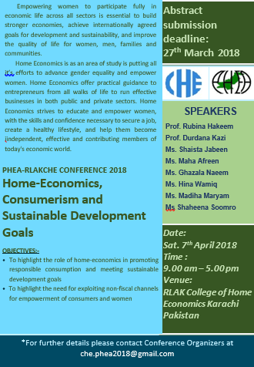
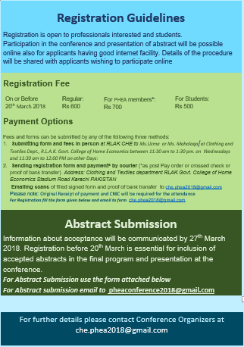
PHEA-RLAKCHE Conference 2018
Home Economics
and Sustainable development Goals
Date : Saturday, 7th April 2018 () Time : 9.00 am – 5.00 pm
Venue: RLAK College of Home Economics Karachi Pakistan
REGISTRATION FORM
Name: ________________________________________NIC No: ________________________
Gender: ale [ ] Female [ ] Title: Mr [ ] Mrs [ ] Ms [ ] Prof [ ] Dr [ ] Other:_________ _
Details of Qualification: (Please write about the relevant degree completed or enrolled in)
Degree ________________ (completed/student) Year __________ Institution____________________________
Details of Occupation
Organisation:___________________ __________________________________
Department: ______________ ______ Position: _______________________________________
Address:___________________________________________ __________________
Postcode: ______________ City:__________________ Country:___________________________
Email: _________________ __ Organization’s Website (if any): ________________________
Tel No: ___________________ Mobile Phone No: ____________________________________

Mode of attendance:
[ ] On site
[ ] On line

Registration Fee:
Please circle the amount and category for which you are submitting the fess

On or Before  20th March 2018 | Regular:  Rs 600 | For PHEA members: Rs 700; | For Students:  Rs 500
After  20th March 2018 | Regular:  Rs 700 | For PHEAmembers: Rs 800; | For Students:  Rs 600

PAYMENT
(Please tick the option you are choosing)
- [ ] Submitting form and fees in person
- [ ] Sending registration form and payment* by courier
- [ ] Emailing scans proof of payment
Please note: Original Receipt of payment and CNIC will be required for attendance.

Signature of applicant __________________ Date ____________________________

PHEA-RLAKCHE Conference 2018
Home Economics
and Sustainable development Goals
Date : Saturday, 7th April 2018 () Time : 9.00 am – 5.00 pm
Venue: RLAK College of Home Economics Karachi Pakistan
Abstract submission form
Applicant’s name: Designation: ______
Institution: _______________________________________________
Category of Abstract: [x] Original Research. [ ] Evidence Based Viewpoints. [ ] Activity Report.

TITLE:
Background:

Objectives:

Methods:

Results:

Conclusion:

Abstract submission guidelines:
Authors who wish to present in PHEA conference 2018 are cordially invited to submit abstracts on topics related. All submitted text will be reviewed by the scientific committee and may be accepted for poster presentation.
Deadline: of abstract submission: 20 March, 2018. Notification of abstract acceptance: 27 March, 2018.
Format: An abstract should not be more than 250 words. Do not include figures and tables. Do not include any reference in the abstract. Following format should be used.
Send your abstracts on pheaconference2018@gmail.com with subject line of the area of home economics. For e.g abstract-Food and Nutrition.

